Upperco Volunteer Fire Co.

2019 Events Calendar
Visit www.uppercovfc.org or Facebook at upperco volunteer fire company
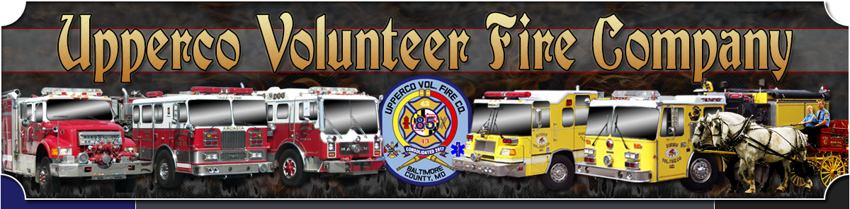
March 23rd - Bull & Oyster Roast 4-9pm
April 13th - Easter Bunny Breakfast 8-11am
May 25th - Hampstead Day 8am - 4pm ( French Fries & Pit Beef)
September 12th - 15th - Steam Show (French Fries)
September 18th - 21st - Music Festival (Facebook - upperco music festival)
October 12th - Gun Raffle
October 19th - Crab Feast 4-9pm
December 7th - Breakfast with Santa Claus 8-11am
December 18th - 25 Day Raffle Starts. Dinner & Final Drawing January 11th
Demolition Derbies - (Facebook - upperco demolition derby)
- May 11th, June 8th, July 13th, August 10th, October 25th & 26th (Sat. 4-9pm & Fri. 7-10)
Bluegrass Jams - (Facebook - arcadia bluegrass festival)
- Every Wednesday Night (Jan - May) (Sept. - Nov.) Doors open 6pm

